Information Requirements for Proposals to Modify Programs

Guidelines
The purpose of these Information Requirements is to outline the information required to allow the MPHEC, an external reader, to assess that a proposed modified program will continue to meet the following assessment criteria:
- Program content, structure and delivery modes reflect a coherent program design that allows for the program objectives and anticipated student outcomes to be achieved, while providing sufficient depth and breadth to meet the standards of quality associated with the credential.
- Clearly defined and relevant program objectives and anticipated student and graduate outcomes.
- Appropriate fit of name, level and content to ensure “truth in advertising” and to facilitate credential recognition.
- Adequate resources (human, physical and financial) to implement and sustain the program
- Program need and viability.
- An academic environment that supports scholarship such as original research, creativity and the advancement of professional knowledge, as relevant to the program (Criterion for graduate programs only).
- Clearly defined collaborative agreements) Criterion for programs offered by two or more institutions only, including articulated programs).
For further information on the Commission’s program assessment process, including detail on the above-noted criteria, please refer to the full policy document, Academic Program Assessment Prior to Implementation Institutions are also encouraged to contact MPHEC staff should they have questions regarding their program proposal.
The MPHEC often receives questions as to whether program modifications ought to be submitted for approval, and whether modifications ought to be submitted using the Information Requirements for Proposals for New Programs. As a rule, modifications that affect approximately 25% or more of the program (see section 2.4.2 of the Policy) require submission. Normally, these modifications ought to be submitted using the Information Requirements for Proposals to Modify Programs. In some instances, however, the modification ought to be submitted as a proposal for a new program given the extent of the change; for example, normally, if the proposal is to introduce a new major or stream within an existing degree program, the proposal ought to be submitted following the Information Requirements for Proposals for New Programs.
The MPHEC acknowledges that institutions may not be able to meet every information requirement. The absence of information must, however, be noted and explained.
Information Requirements
- Program Identification
  - Submitting institution(s)
Click here to enter text.
  - Faculty(ies)
Click here to enter text.
  - School(s)
Click here to enter text.
1.4 Department(s)
Click here to enter text.
  - Program name (where applicable, former and proposed)
Click here to enter text.
  - Program type (e.g., undergraduate, post-baccalaureate, master’s, doctoral)
Click here to enter text.
  - Credential(s) granted (where applicable, former and proposed)
Click here to enter text.
1.8 Description of the timeframe/phase-out plan for the existing program and students/phase-in plan for the modifications, where applicable:
1.8.1 Proposed start date for modified program, considering all required approvals including the MPHEC’s. Select Date
1.8.2 Anticipated date of completion of last student enrolled in existing program.
Select Date
1.8.3 Any other information to assist the MPHEC in understanding how the program will transition from the existing, MPHEC-approved program, to that being proposed.
Click here to enter text.
1.9 Institutional program code(s), as stored in the post-secondary institution’s administrative files, that is reported under PSIS (Post-Secondary Student Information System) (element IP 2000) (where applicable, former and proposed).
Click here to enter text.
1.10 Dates of Senate (or equivalent) and Board approval of the proposed program modification.
(1) Senate Select Date (2) Board Select Date
- Description of the Proposed Program Modification
2.1 Description of the type of change (e.g., course change, addition of work placement, change to online delivery).
Click here to enter text.
2.2 Description of the purpose of the change (e.g., following the evolution of the discipline, accommodating the clientele to be served, establishing a better focus, resulting from an external review (provide details). If the proposed modification includes a name change, provide a rationale for the choice of new name/credential, including comment on the process of selecting the name and credential(s).
Click here to enter text.
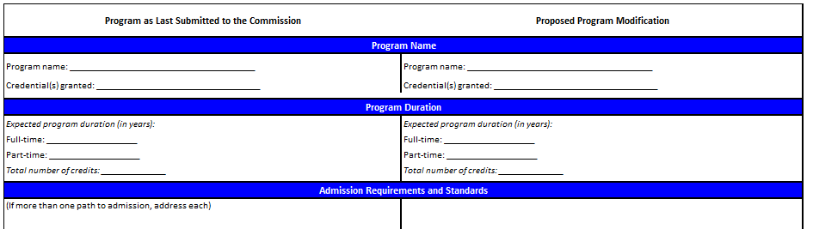
2.3 Using the table provided as an example (see “Tables to be included in Proposals for Modified Programs – Table 2.3 Roll-Out”), provide a side-by-side comparison of the program as it was last submitted to the Commission and the proposed modifications: If unable to provide information on the program as last submitted to the Commission, please provide a full description of the modified program.
2.4 Using the table provided as an example (see “Tables to be included in Proposals for Modified Programs – Table 2.4 Student Outcomes”), identify the mechanisms through which student/learning outcomes will be achieved.
2.5 In the case of articulated or other collaborative programs, changes to the inter-institutional agreements (or equivalent) should be stated and explained; append to the proposal a copy of the revised agreement.
Click here to enter text.
2.6 Confirm whether enrolments in the program are anticipated to remain the same, increase or decrease as a result of the program modification. If enrolments are expected to change, identify the degree of change expected (e.g., an additional 10-15 students are expected to enrol each year as a result of the modification for a total of 65 students per year once fully implemented).
Click here to enter text.
2.7 Explanation of the impact the proposed modification will have on existing resources. If no impact is anticipated, provide a rationale for this conclusion.
Click here to enter text.
2.8 Using the table provided as an example (see “Tables to be included in Proposals for Modified Programs - Table 2.8 Budget”), provide a revised budget that accounts for the proposed program modifications.
2.9 Potential impact of the change on other programs at the institution (e.g., reduction in required elective options/cross-listed courses) and how this will be addressed.
Click here to enter text.
2.10 An indication of other institutions involved, or that have been consulted.
Click here to enter text.
2.11 Description of the accreditation requirements and/or implications resulting from the modification.
Click here to enter text.
2.12 In the event the modification includes a change in delivery mode to include technologically-mediated or other distance delivery:
2.12.1 Describe how the delivery mode(s) will contribute to and enhance learning and create a community both among students and between students and faculty.
Click here to enter text.
2.12.2 Description of support available to faculty (required and optional pedagogical training, technical support for course design and then instruction, etc.) and to students (required and optional orientation to technology use, communications on expectations for interaction and performance, etc.).
Click here to enter text.
2.12.3 Describe faculty availability to students, faculty-to-student feedback, and opportunities for interaction with other students, within this program.
Click here to enter text.
2.12.4 Describe the mechanisms in place to ensure the following for the proposed program:
- Reliable, sufficient, and scalable course-management systems
- Appropriate hardware, software, and other technological resources and media
- Well-maintained and current technology and equipment
- Sufficient infrastructure to support existing services and expansion of online offerings
Click here to enter text.
- Additional Information
3.1 Any other information that the institution feels will assist the MPHEC in its understanding and assessment of the proposed modification. Reports of internal or external assessments, and a summary of the response, where applicable, would be helpful.
Click here to enter text.
Appendices
Please ensure that each of the following are appended/included, as applicable, when submitting a completed program proposal:
☐ A list of appendices to the program proposal
☐ Detailed course descriptions for each compulsory and required elective course including: calendar entry, course objectives, main themes, prerequisites, student evaluation (assessments), and preliminary bibliography (and availability).
☐ Written correspondence/reports from (internal or) external experts consulted during program development
☐ Budget
☐ Policies, guidelines and practices pertaining to technology-mediated and other distance delivery modes
☐ (Revised) Signed inter-institutional agreements (for articulated and other collaborative programs)
☐ Letter of AACHHR support (for health-related programs)
Checklist
☐ All of the information requirements have been addressed
☐ All relevant appendices are attached
☐ Phase-in/phase-out plan has been provided
☐ Institutional program codes have been provided
☐ Side-by-side comparisons are complete
☐ An explanation of the impact the modification will have on resources is provided
☐ An explanation of the impact the modification will have on other programs is provided
☐ An explanation of how comments from experts/assessors/consultants etc. were addressed is included in the proposal
☐ Any additional information to help the MPHEC assess the quality of the proposed program
☐ Signature (or appended letter) confirming the collaborative submission, and principal applicant, where applicable

