ANNUAL REPORT
2017-2018

NB/PEI EDUCATIONAL COMPUTER NETWORK
Supporting higher education in Atlantic Canada
for over 45 years

April 1, 2017 - March 31, 2018

MISSION
To ensure high quality Information and Communication Technology (ICT) services to all member institutions in New Brunswick and Prince Edward Island

VISION
To apply our collective skills and resources to the betterment of the New Brunswick and Prince Edward Island higher education communities through the deployment of state of the art technology while saving money for our provinces and institutions

VALUES

Honesty

Trust Col
Visit our website at: http://www.nbpei-ecn.ca (English) http://rie-nbipe.ca/(French)
II

NEW BRUNSWICK and PRINCE EDWARD ISLAND EDUCATIONAL COMPUTER NETWORK MEMBERS

COLLÈGE COMMUNAUTAIRE DU NOUVEAU-BRUNSWICK
725 College Street P.O. Box 266
Bathurst, New Brunswick E2A 3Z2
Tel.: (506) 547-2063 Fax: (506) 547-2741 www.ccnb.ca

HOLLAND COLLEGE
140 Weymouth Street
Charlottetown, Prince Edward Island C1A 4Z1
Tel.: (800) 446-5265 Fax: (902) 629-4239 www.hollandcollege.com

MARITIME COLLEGE OF FOREST TECHNOLOGY
1350 Regent Street
Fredericton, New Brunswick E3C 2G6
Tel.: (506) 458-0199 Fax: (506) 458-0652 www.mcft.ca

MARITIME PROVINCES HIGHER EDUCATION COMMISSION
82 Westmorland, Suite 401
P.O. Box 6000
Fredericton, New Brunswick E3B 5H1
Tel.: (506) 453-2844 Fax: (506) 453-2106 www.mphec.ca
NEW BRUNSWICK COMMUNITY COLLEGE
284 Smythe Street
Fredericton, New Brunswick E3B 3C9
Tel.: (506) 462-5012 Fax: (506) 462-5008 www.nbcc.ca

MOUNT ALLISON UNIVERSITY
155 Main Street
Sackville, New Brunswick E4L 1B5
Tel.: (506) 364-2300 Fax: (506) 364-2299 www.mta.ca

ST. THOMAS UNIVERSITY
51 Dineen Drive
Fredericton, New Brunswick E3B 5G3
Tel.: (506) 452-0640 Fax: (506) 450-9615 www.stu.ca

UNIVERSITÉ DE MONCTON
18 Antonine-Maillet Avenue
Moncton, New Brunswick E1A 3E9
Tel: (506) 858-4113 Fax: (506) 858-4544 www.umoncton.ca
UNIVERSITY OF NEW BRUNSWICK
P.O. Box 4400
Fredericton, New Brunswick E3B 5A3
Tel.: (506) 453-4573 Fax: (506) 453-5016 www.unb.ca

UNIVERSITY OF PRINCE EDWARD ISLAND
550 University Avenue
Charlottetown, Prince Edward Island C1A 4P3
Tel.: (902) 566-0400 Fax: (902) 566-0420 www.upei.ca
III

Message from the Chair

On behalf of the NB/PEI Educational Computer Network, I am pleased to present our 2017-2018 Annual Report. The ECN has a fantastic track record of effective collaboration for the benefits of its members. This document highlights the ECN’s activities and accomplishments over the past fiscal year.

I would like to begin by thanking Scott Chamberlain (UNB Fredericton) for chairing the Network Committee this past year. I would also like to thank our respective provincial governments, fellow Board and Network Committee members, partners and stakeholders for their continuous support, hard work and dedication, which make this network such a success.
.
The NB/PEI ECN launched a new website in May of 2017 providing the public with an informative overview of who and what the ECN represents. One of the ECN’s primary focuses is on Cyber Security and the eminent threats on our network and our institutions. The ECN has taken steps to improve their firewalls over the past year and will launch a Cyber Security project in the spring of 2018 that will involve Threat Risk Assessment for all member institutions. This initiative along with other measures that have been put in place to protect our network from attackers are all possible because of the strength and expertise of this consortium.

As you read the pages ahead, I hope you will find out more about the accomplishments of the ECN this year.
Dr. Robert Campbell

Chair, ECN Board of Directors

IV
Table of Contents

Overview 6
More about ECN 6
Governance 6
Network Committee 8
Designated Installation 8
Meetings 9
Strategy 9
Communications and collaboration tools
Consortium Security
Network sustainability
Financial Operation 10

Appendices
APPENDIX I: Board members as of March 31, 2018
APPENDIX II: NB REN – Research and Education Network
APPENDIX III: ECN Service Area/Project

APPENDIX IV: Statement of Revenue and Expenditures
V
Overview

The NB/PEI Educational Computer Network (ECN), founded in 1970, connects all of the universities, community colleges and the Maritime College of Forest Technology in New Brunswick (NB) and UPEI and Holland College in Prince Edward Island (PEI). The primary service provided by the network is connectivity among its members and to the wider world. Many additional benefits are enjoyed by members, notably joint purchasing and licensing, shared IT services, professional development, cyber security and the delivery of network-based services and information exchange.

This approach has enabled all ECN members to realize the benefits of a high capacity, high speed data communications network at a reasonable cost, regardless of size. It also allows members to take advantage of economies of scale not available to individual member institutions, and ensures that smaller institutions receive the same level of service as larger ones. In fact, ECN reduced IT costs for members and thus funders including the provinces, an annual average of $1.3M over the past five years which is a 100% return on investment. In the last two years, the yearly savings have been even more, at $1.5M. Through economies of scale, and with expertise contributed by all, ECN members pay less for many software applications, connections to commercial internet services, and equipment, than they could independently. Finally, members become stronger on the national front by providing a united voice with respect to the collective needs of New Brunswick and Prince Edward Island research and education sector.

ECN is one of the oldest yet most innovative of the higher education IT consortia across Canada. ECN members benefit from a strong governance and management model, and a reasonably secure budget that ensures continuity and flexibility. ECN’s collaborative and collegial culture firmly supports its many accomplishments.

More about ECN

Following a pilot project in the late 1960's, the NB Educational Computer Network was formed in 1970 when the New Brunswick Higher Education Commission, Mount Allison University, l’Université de Moncton, the University of New Brunswick, and St. Thomas University entered into an agreement to share computer-processing services. In 1974, the newly formed Maritime Provinces Higher Education Commission (MPHEC) assumed stewardship of the Agreement and in 1975, the University of Prince Edward Island joined as a full member, establishing the NB/PEI ECN. The signing of a five-year agreement, from May 1, 1992 to April 30, 1997, formalized the addition of Holland College as the next member of the group. A subsequent five-year agreement (May 1, 1997 to April 30, 2002) witnessed the addition of the Maritime Forest Ranger School (now the Maritime College of Forest Technology) to the list of member institutions of the ECN. The current five-year agreement (January 1, 2017 to March 31, 2022) witnessed the addition of the Collège communautaire de Nouveau Brunswick (CCNB) and the New Brunswick Community College (NBCC) to the list of member institutions.

The ECN is overseen by a Board of Directors, consisting of the Presidents of the member institutions and the Chief Executive Officer of the MPHEC. The overall management and operation of the network and the associated services is the responsibility of a Network Committee consisting of the Senior IT positions from each member institution. The ECN is funded by the Provinces of New Brunswick and Prince Edward Island, through the funding administered by the MPHEC, and is topped-up with some direct funding from some of the institutions.
Page|6
Page|6
In addition to providing connectivity among its members, the New Brunswick portion of the network also connects New Brunswick member institutions to the wider world through a shared connection to the Canadian Advanced Research Network (CANARIE) and through CANARIE to the world. The Prince Edward Island portion of the network also has a direct connection to CANARIE. ECN has been highly successful in attracting capital investment from the federal and provincial governments, with over $600k contributed to the development and expansion of the NB research and education communications network over the last three years. Inestimable value from collaboration, cooperation, and highly professional relationships among the members has contributed greatly to ECN’s reputation across Canada as having one of the best governance, management, and operating models among similar organizations.
ECN highlights for 2017-2018 include:
- The NB/PEI Educational Computer Network (ECN) continued to successfully provide connectivity among its members and to the wider world, just as it has for the past 46 years.
- The ECN website was redesigned and launched in May 2017 with new content.
- The Communications Team created a Terms of Reference and a Communication Plan.
- A successful Desktop and Laptop tender was awarded for a two-year period with three, one-year extension options.
- The ECN implemented a Hosted External DNS provided by CIRA
- The ECN held a successful planning session on Shared Services resulting in identifying what “Shared Services” means to the ECN as a whole along with the development of a high level roadmap and a list of possibilities for shared services that has been outlined in a “ECN Projects and Initiatives” document. Cross institutional teams have been created to address Cyber Security, Office 365 and Windows 10.
- The Cyber Security project team evaluated and awarded the tender to the successful vendor before the end of March 2018. The Cyber Security Project will be underway in the first quarter of 2018-19 beginning with a Threat Risk Assessment process for ECN members.
- The ECN Firewall project went live on July 19, 2017, with the creation of a firewall management team and the development of a change management framework and policy.
- The 2017 technical workshop was held in November with over 90 participants. The purpose of the workshop was to engage the technical staff in an overview of Windows 10 and Office 365. Two representatives from Microsoft were also on hand for a presentation and Q&A session.
- End Point Protection (eSet) was implemented for most ECN members as the new Anti-virus solution with a three-year contract.
- A diverse path of network fibre from Sackville, NB to Amherst, NS was purchased to provide MTA with an alternate path in case of disruption of service and to strengthen and improve the network.
- Additional bandwidth was purchased on the southern NB network for alternate paths, disaster recovery and to prepare for upcoming projects and requirements. This covers the ring between Fredericton and Saint John and Saint John and Moncton.
- The ECN will partner with CANARIE in a Security Information and Event Management (SIEM) solution. An opportunity to be part of the first security project identified for the NREN Direct Funding Program. This project will provide visibility into cybersecurity threats on the network while providing the NREN with a strong base to develop a comprehensive security strategy for the organization.
Page|7
Page|7

Governance

Board of Directors

The ECN is governed by a Board of Directors (Board) consisting of the following members:
1. The President of Holland College
2. The Executive Director of the Maritime College of Forest Technology
3. The Chief Executive Officer of the MPHEC
4. The President of Mount Allison University
5. The President of St. Thomas University
6. Le recteur de l’ Université de Moncton
7. The President of the University of New Brunswick
8. The President of the University of Prince Edward Island
9. The President and CEO of the New Brunswick Community College
10. La présidente-directrice générale du Collège communautaire du Nouveau-Brunswick

The Chairperson, whose term is five years, renewable for a second five-year term, is elected by the Board. Quorum is six members. Decisions must have the unanimous consent of those members voting (with the exception of a vote declaring that the service of the designated installation is inadequate; in which case the designated member is ineligible to vote). Generally, two meetings are held each year. The MPHEC performs secretarial duties for the Board and manages the budget on behalf of all the members.

Network Committee

The NB/PEI Educational Computer Network Committee (Network Committee) includes one voting representative nominated by each of the parties of the Agreement as well as a voting member who represents the Network Operations. An alternate representative to the Network Committee is also appointed. Members and alternates are appointed for an indefinite period or are replaced upon recommendation in writing to the Chairperson of the Board. The Chairperson of the Network Committee is nominated by the Network Committee, and is non-voting, and is approved by the Board for a maximum of two 2-year terms. The MPHEC representative is the Secretary of the Network Committee. The Network Committee meets 5-6 times annually. The duties of the Network Committee are listed in Appendix A of the ECN Agreement. The Network Committee makes decisions by unanimous consent of members voting.

The Network Committee submits, on or before January 15, a recommended Network Plan and Budget to the Vice-President (Finance) of each of the member institutions for confirmation. Once confirmed, the Network Committee submits the Network Plan and Budget to the Board for approval. At the end of the year, the Committee drafts an annual report for approval by the Board showing its performance compared to the Network Plan from the beginning of the fiscal year.

Designated installation

UNB is the designated, and the major, installation for the Network. Computing facilities and Information and Communication Technology (ICT) services are provided by UNB to all ECN members as detailed in Appendices B and C of the ECN Agreement.
Page|8
Meetings

The ECN Network Committee met six times in 2017-2018:

May 30, 2017 Collège communautaire du Nouveau-Brunswick, Dieppe Campus
July 12, 2017 | University of Prince Edward Island, Charlottetown, PEI
September 27, 2017 | Université de Moncton, Edmundston Campus
November 15, 2017 | St. Thomas University, Fredericton NB
January 12, 2018 | Université de Moncton, Moncton Campus
March 16, 2018 | Mount Allison University, Sackville, NB
A list of the Board and Network Committee members is included in Appendix I.

Appendix II includes:
A New Brunswick map displaying the physical network connections and their relative bandwidth as well as CANARIE links. The red and blue lines are leased carrier services while the green lines are owned fibre optic links. Shared Internet connections are located in Fredericton and Moncton.

A New Brunswick map displaying the connected campuses of the partner institutions; there are a total of 36 campuses connected in 15 cities, towns, and villages.

The Prince Edward Island map shows the connected locations and the CANARIE link.

Strategy

The key shared service of the ECN is connecting member institutions via a high-speed, high-capacity research and education network. Members also jointly purchase and deploy IT products and services, with anti-virus, SharePoint, firewalls, and anti-spam software being recent examples of successful collaborations.

Building on recent successes such as data center consolidation and disaster recovery, ECN is updating its strategic plan to focus on the following areas:
Communication and collaboration tools: The ECN will continue to grow the use of SharePoint (a Microsoft software platform used for file sharing and co-editing, document and records management, and collaboration projects) at individual ECN sites, providing centralized SharePoint support with a dedicated employee at the host site (to develop and manage the SharePoint site for all). As almost all members use Microsoft’s Office365 cloud services for email, calendaring, individual file storage, and others, we will increasingly take a consortia view when evaluating and deploying services via O365, for example video-conferencing via Skype for Business, and telephony (Voice over IP (VoIP)).
Consortium Security: A common requirement among all of us is to keep our IT networks, equipment, and data secure from a host of external and internal threats. The 24/7, highly volatile nature of IT security strains the resources of all our members, and we are pressed to keep up with even minimal standards. As a consortium, we recently tendered for next generation firewall technology, which is now being deployed at several sites. Furthermore, several other initiatives have come to our attention which we will participate in as they come to readiness; for instance, CANARIE, the federal partner in the national research and education network, is sponsoring a project to procure and support security incident and event management (SIEM) software at institutions across the country.
Page|9
ECN feels it can vastly benefit by deploying these critical monitoring and alerting tools at all our member sites at a cost that makes sense yet will include the expert support required to ensure successful deployment and use. It is recognized that end-user cybersecurity awareness and education is a key gap at many institutions, and ECN will seek out tools and processes to help us all meet this need. Finally, we will be sharing cybersecurity incident response plans and templates as they are developed.
Network sustainability and improvement: Hundreds of kilometers of dedicated fibre-optic cables, combined with millions of dollars of sophisticated network equipment, are our biggest and most important assets, and provide the main platform upon which ECN operates. To ensure the network continues to perform efficiently and economically in a time of ever increasing demand by members and their use of cloud based solutions, ECN will focus on network development, extending it where needed, while building in resiliency and redundancy wherever possible. Equipment renewal is a perennial challenge, and ECN will thoughtfully yet creatively manage its resources to ensure future reliability, stability, and capacity.
A table of strategic initiatives is in Appendix III.
Financial operations

A copy of the approved budget vs actual expenditures for 2017-2018 (showing a surplus of $189,484 (NB: $239,350; PEI: $-49,866) as well as the balance of the ECN committed funds as of March 31, 2018 is included in Appendix IV. New Brunswick continues to see significant savings on Internet costs over the year thanks to discounted rates received from the provider. There were no hardware expenditures. Software was slightly higher than projected but offset by the savings in the CAF membership and maintenance expenditures. Meeting costs increased in both the NB and PEI budget due to an increase in our membership and also a change in the meeting format, which required overnight travel. Collaborative, Shared Services and the NBREN are also below budget expectations. The firewall and security projects under Collaboration were initiated in 2017-18 but will only realize significant expenditures in 2018-19. Finally, the contribution to the NB Research and Education Network (REN) was lower than budgeted again because of reduced rates. In PEI, the planned draw from the reserves of $50K was approved and expended by both Holland College and UPEI in preparation for the Firewall project. The PEI deficit was as expected and planned in the 2017-18 PEI budget. Most PEI budget line items fell in line with what was proposed with only the Collaborative Project being less than the budgeted expectation. The ECN’s accumulated surplus of $1,474,245 (NB: $1,412,772; PE: $61,473) will be used to fund initiatives such as the Cyber Security and Firewall Projects currently underway and future projects as identified in the strategic plan.

Page|10
APPENDIX I

Board Members as of March 31, 2018 were:

Institution | Representative
Mount Allison University | Dr. Robert Campbell (Chair)
St. Thomas University | Ms. Dawn Russell
Université de Moncton | M. Jacques Paul Couturier
University of New Brunswick | Dr. Eddy Campbell
University of Prince Edward Island | Dr. Alaa Abd-El-Aziz
Holland College | Dr. Brian McMillan
Maritime College of Forest Technology | Mr. Tim Marshall
MPHEC | Ms. Catherine Stewart (Interim CEO)
CCNB | Ms. Liane Roy
NBCC | Ms. Marilyn Luscombe

Network Committee Representatives and Alternates as of March 31, 2018 were:

Institution | Representative | Alternate
Mount Allison University | Mr. Helmut Becker | Mr. Peter Crawshaw
St. Thomas University | Mr. Dan Crabbe | Mr. Robert Brewer
Université de Moncton | M. André Lee | Ms. Rina Robichaud
University of New Brunswick | Mr. Terry Nikkel | Mr. David Totton
New Brunswick Network | Mr. Peter Jacobs | Mr. John Jackson
University of Prince Edward Island | Mr. Dana Sanderson | Mr. Blair Vessey
Holland College | Mr. Richard MacDonald | Mr. Greg Mermuys
Maritime College of Forest Technology | Mr. Jim Bowen | Mr. Mike Boucher
MPHEC | Ms. Rachael Anderson | Mr. Scott Stonehouse
CCNB | Mr. Tony Roy | Mr. Marc-André Arseneau  Arseneau
NBCC | Mr. Darren Rose | Mr. Edgar Lazar

The Chair of the Network Committee was Scott Chamberlain.
Appendix II
Page|11
Page|11

NB REN – Research and Education Network

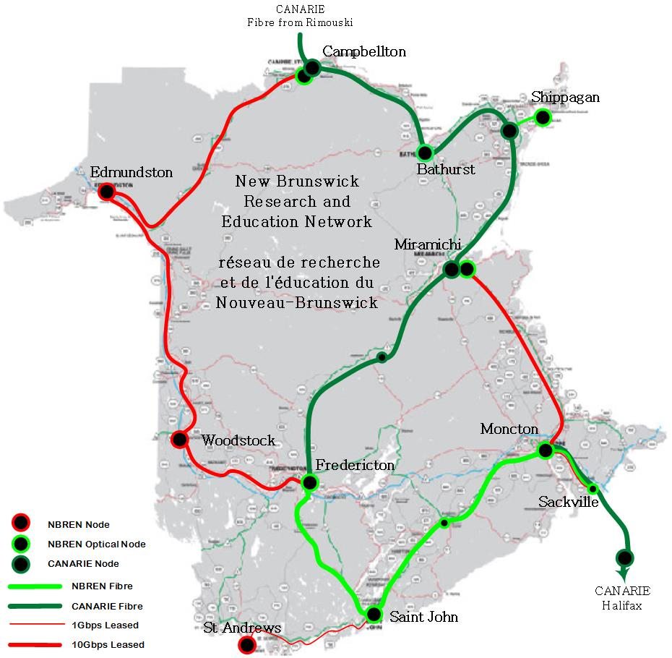

Page|12

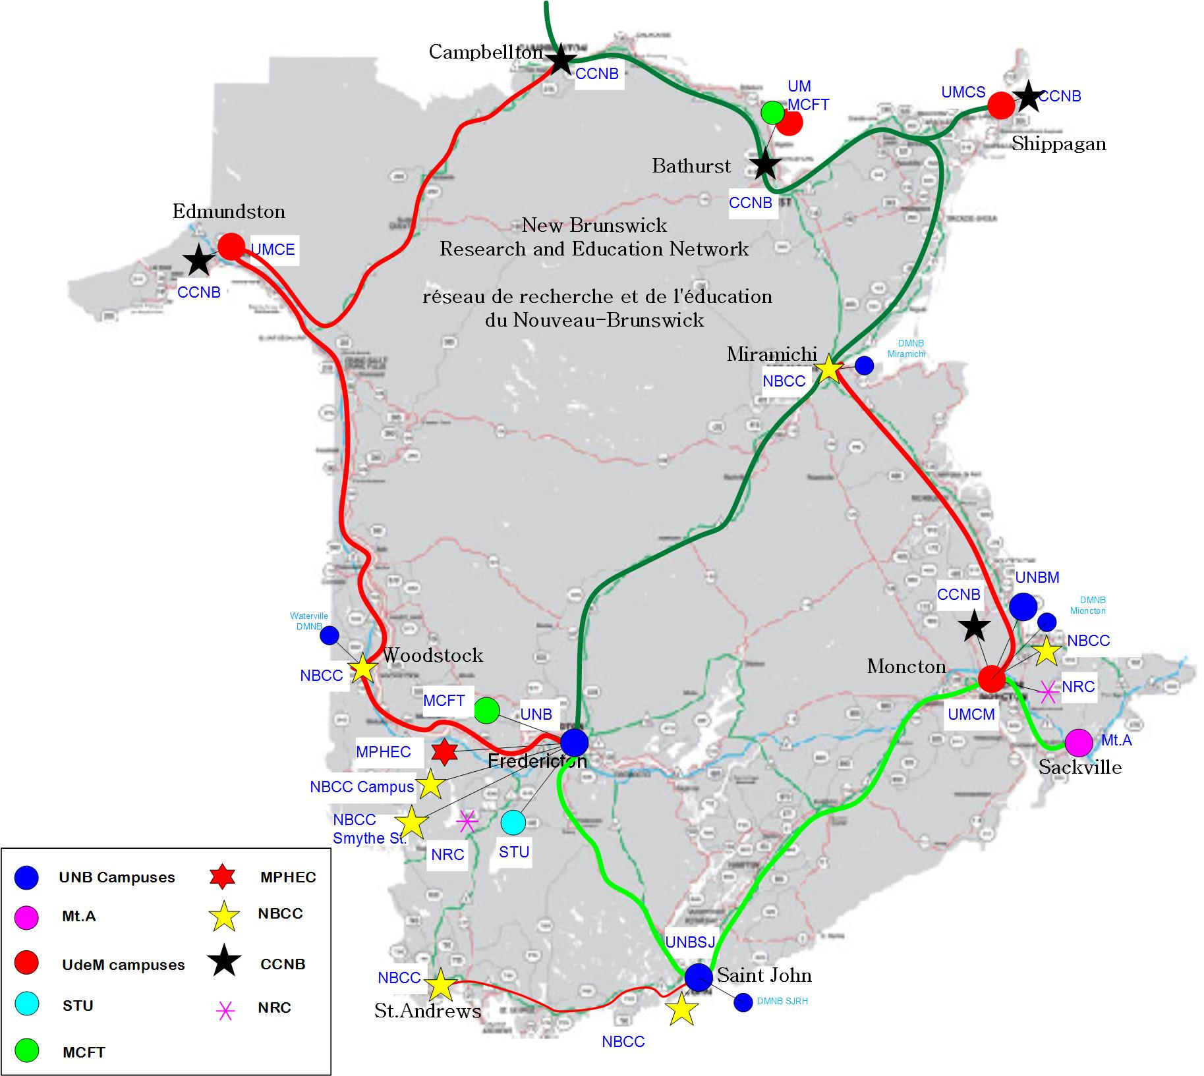
Page|13

Prince Edward Island Research and Education Network

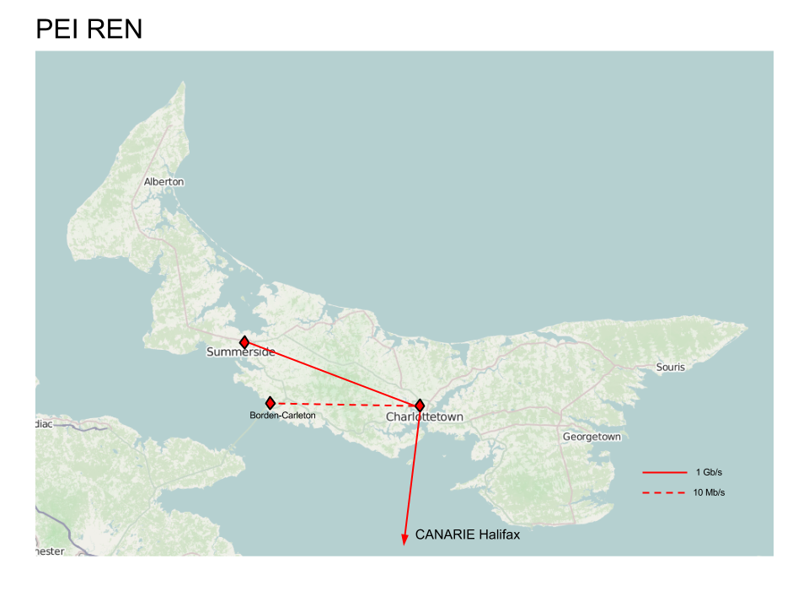

Page|14
Appendix III
ECN Service Area / Project | Objectives  2017/18 | Objectives  2018/19 | Objectives  2019/20
Connectivity | Improve bandwidth in southern NB  Internet services RFP  Review Campus Connect with Firewalls/Fortinet
Shared Services | Analysis of O365 tools  SharePoint opportunities  Cybersecurity projects:  SIEM, user education and awareness
Joint Purchasing | Anti-Spam contract  Renewal (expires: Sept 2018)
Professional Development | AUCTC  ECN Workshop | AUCTC  ECN Workshop | AUCTC  ECN Workshop
National Representation and Sharing of Information and Best Practices | NREN GC  CIO Advisory Committee | NREN GC  CIO Advisory Committee | NREN GC  CIO Advisory Committee
Organizational | Implement Communications Plan | Communications Plan | Communications Plan

Page|15
APPENDIX IV
EDUCATIONAL COMPUTER NETWORK
NEW BRUNSWICK AND PRINCE EDWARD ISLAND STATEMENT OF REVENUE AND EXPENDITURES*

PERIOD ENDED: 3/31/2018

Budget Actual

Account Description 2017-2018 2017-2018

Revenue  Provincial Transfers | 946,548 |  | 946,538
Direct Funding from institutions | 354,476 |  | 354,476
External fees for service | 95,733 |  | 0.00
Total Revenue | 1,396,757 |  | 1,301,014
Expenditures
Network Shared Services
UNB as the designated installation (service provider) | 216,291 |  | 216,291
Total Network Shared Services | 216,291 |  | 216,291
Telecommunications
PEI Provincial Lines & Internet Access | 57,047 |  | 57,055
NB Internet Access | 126,000 |  | 48,606
Total Telecommunications | 183,047 |  | 105,661
Hardware, software, maintenance
Hardware | 95,608 |  | 50,000
Software | 88,171 |  | 95,379
CAF Maintenance | 23,200 22,000 |  | 21,167
Maintenance | 39,708 |  | 38,583
Total Hardware, Software, Maintenance | 246,687 |  | 205,129
Meetings and Collaboration
Network Committee | 15,000 |  | 27,660
Collaborative Projects | 207,699 |  | 116,257
ECN SharePoint Services | 110,500 |  | 68,731
Total Meetings and Collaboration | 333,199 |  | 212,648
NBREN and GigaPOP
NBREN CORE | 394,800 |  | 371,800
NBREN Additional Connections | 27,733 |  | 0
NB GigaPOP Services | 45,000 |  | 0
Total NBREN and GigaPOP | 467,533 |  | 371,800
Total Expenditures | 1,446,757 |  | 1,111,530
Net revenue (net loss) | -50,000 |  | 189,484
NB & PEI Committed Funds Balance as at March 31, 2018:  Balance, April 1, 2017 |  |  | 1,284,461
Net revenue (loss) for the year |  |  | 189,484
Balance, March 31, 2018 |  |  | 1,473,945

*as per MPHEC audited financial statements
Page|16

EDUCATIONAL COMPUTER NETWORK
NEW BRUNSWICK
STATEMENT OF REVENUE AND EXPENDITURES*
PERIOD ENDED: 3/31/2018
 | Budget |  |  | Actual
Account Description | 2017-2018 |  |  | 2017-2018
Revenue
Provincial Transfers | 860,938 |  |  | 860,938
Direct contributions | 328,000 |  |  | 328,000
External Fees for Service | 95,733 |  |  | 0
Total Revenue | 1,284,681 |  |  | 1,188,938
Expenditures
Network Shared Services
UNB as the designated installation (service provider) | 205,477 |  |  | 205,476
Total Network Shared Services | 205.477 |  |  | 205.476
Telecommunications
Internet Access | 126,000 |  |  | 48,606
Total Telecommunications | 126,000 |  |  | 48,606
Hardware, software, maintenance
Hardware | 45,608 |  |  | 0
Software | 69,655 |  |  | 75,350
CAF membership | 18,200 |  |  | 16,167
Maintenance | 29,708 |  |  | 25,314
Total Hardware, software, maintenance | 163,171 |  |  | 116,831
Meetings and Collaboration
Network Committee | 12,000 |  |  | 22,284
Collaborative Projects | 200,000 |  |  | 115,860
Shared Services | 110,500 |  |  | 68,731
Total Meetings and Collaboration | 322,500 |  |  | 206,874
NBREN and GigaPOP
NBREN CORE | 394,800 |  |  | 371,800
NBREN Additional Connections | 27,733 |  |  | 0
NB GigaPOP Services | 45,000 |  |  | 0
Total NBREN and GigaPOP | 467,533 |  |  | 371,800
Total Expenditures | 1,284,681 |  |  | 949,588
Net revenue (net loss) | 0 |  |  | 239,350
NB Committed Funds Balance as at March 31, 2018:
Balance, April 1, 2017 |  |  |  | 1,173,122
Net revenue (loss) for the year |  |  |  | 239,350
Balance, March 31, 2018 |  |  |  | 1,412,472

*as per MPHEC audited financial statements
Page|17
EDUCATIONAL COMPUTER NETWORK PRINCE EDWARD ISLAND
STATEMENT OF REVENUE AND EXPENDITURES*
PERIOD ENDED: 3/31/2018
 | Budget |  | Actual
Account Description | 2017-2018 |  | 2017-2018
Revenue
Provincial Transfers | 85,600 |  | 85,600
Direct HC/UPEI Transfer | 26,476 |  | 26,476
Total Revenue | 112,076 |  | 112,076
Expenditures
Network Shared Services
UNB as the designated installation (service provider) | 10,814 |  | 10,815
Total Network Shared Services | 10,814 |  | 10,815
Telecommunications
Provincial Lines & Internet Access | 57,047 |  | 57,055
Total Telecommunications | 57,047 |  | 57,055
Hardware, software, maintenance
Hardware | 50,000 |  | 50,000 50,00
Software | 18,516 |  | 20,030
CAF Maintenance | 5,000 |  | 5,000
Maintenance | 10,000 |  | 13,269 0
Total Hardware, software, maintenance | 83,516 |  | 88,299
Meetings and Collaboration
Network Committee | 3,000 |  | 5,376
Collaborative Projects | 7,699 |  | 398
Total Meetings and Collaboration | 10,699 |  | 5,774
Total Expenditures | 162,076 |  | 161,942
Net revenue (net loss) | -50,000 |  | -49,866
PEI Committed Funds Balance as at March 31, 2018:
Balance, April 1, 2017 |  |  | 111,339
Net revenue (loss) for the year |  |  | -49,866
Balance, March 31, 2018 |  |  | 61,473

*as per MPHEC audited financial statements

Page|18

